C2-S13 GAME
Bug Quest!
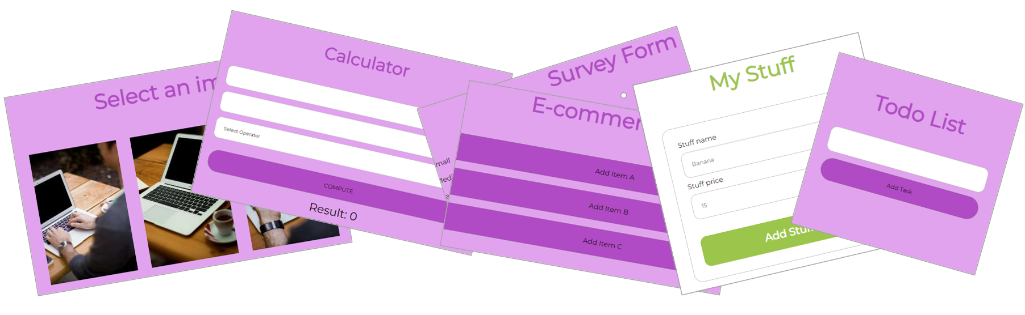
the team with the most validated fixes wins!

BUG | Your process to find the bug | How did you solve the bug? | Trainer validation
# 1 | - Reading code  - Use the debugger  - Read the error stack  - Add some log | Example:  I changed the start index in the loop | OK / NOK
# 2 | - Reading code  - Use the debugger  - Read the error stack  - Add some log |  | OK / NOK
# 3 | - Reading code  - Use the debugger  - Read the error stack  - Add some log |  | OK / NOK
# 4 | - Reading code  - Use the debugger  - Read the error stack  - Add some log |  | OK / NOK
# 5 | - Reading code  - Use the debugger  - Read the error stack  - Add some log |  | OK / NOK
# 6 | - Reading code  - Use the debugger  - Read the error stack  - Add some log |  | OK / NOK
# 7 | - Reading code  - Use the debugger  - Read the error stack  - Add some log |  | OK / NOK
# 8 | - Reading code  - Use the debugger  - Read the error stack  - Add some log |  | OK / NOK

